Environmental Policy Document No; 05

CLARKE CONTRACTS PLASTERING & FLOORING makes the following commitments to environmental improvements:

- We will comply with all relevant environmental legislation at our own premises and on construction sites which we are working on.

- We will continually improve our environmental performance through setting objectives and targets.

- We will gather data and submit this to NVIR-O-CERT for industry KPI monitoring (Key Performance Indicators).

- We will aim to prevent and minimise pollution from all our operations.

- We will aim to minimise waste and reduce the amount of waste sent to landfill.

- We will aim to reduce energy and water usage from our operations.

- We will protect the natural and built environment and enhance this where possible.

We will ensure that all our staff and sub-contractors working on our behalf are aware of and comply with this policy.

This policy will be displayed at our premises and on construction sites where we operate as main contractor. It is available on request from our office.

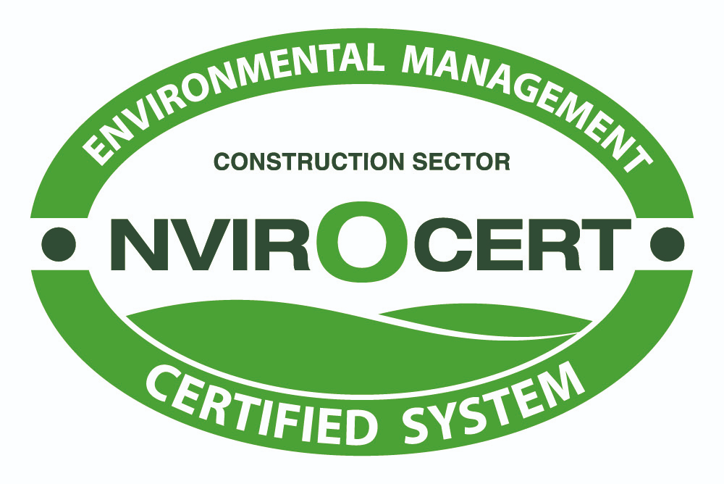

Brendan Clarke
Managing Director
December 2018
Review Date Decemebr 2019

